

AHU CONTROLLER TEST DATA SHEET

P/N: AHU-L (47) 413-8005-1 Date: 08/03/2018 Time: 17:46

S/N: 999 Tested by: ghfd

Hardware Rev: BLDC_60A_V6 Approved by: ghfd

Software Rev:

Tester Software Version: 1.2

Equipments Used

Equipments Model No Serial No

Power Supply

Digital Multimeter

CAN Interface

Resistance Decade Box

PC

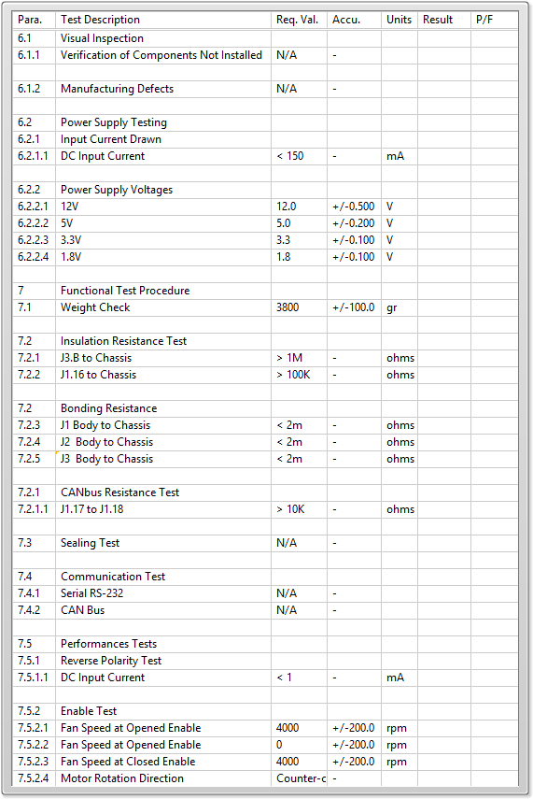

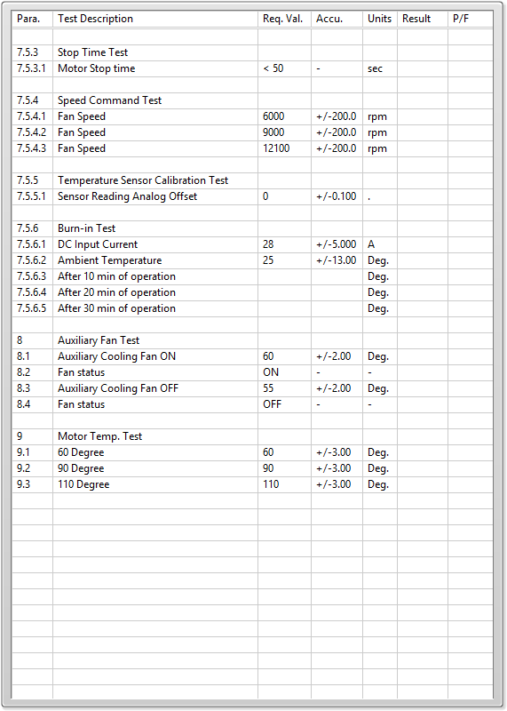

General result:

Test-Operator:____ ghfd_________ Q.A.:__________________________